Detailed Design Document
Sponsor Name:
Document ID: Detailed Design Document_ Consumable
Blueprint Design Document ID: LIMS_Phase2_Blueprint Design_Consumable_CN_Final

Version No. | Authorized by | Approval date
1.00

Table of Contents
1 Table of Contents 2
1 Objective 4
2 Detailed Architecture 4
2.1 Consumables in SampleManager 4
2.1.1 Functionality Overview 4
2.1.2 Forms Modification 5
2.1.2.1 Stock Form Modification 5
2.1.2.2 Label Template. 5
2.1.2.3 Stock Batch Creation Rules 6
2.1.2.4 Sample Login 8
2.1.2.5 Sample Process 9
2.1.2.6 Stock Batch Release 9
2.1.2.7 Automatic Consumption of Stock Batches During Testing 9
2.1.2.8 Modifying Stock Batch Consumed for a Test 10
2.1.3 .NET Tasks 11
2.1.3.1 PrintLableTask 11
2.1.3.2 CheckMLPTask 11
2.1.3.3 StockBatchReleaseTask 12
2.1.3.4 AutoConsumptionTask 12
2.1.3.5 ReturnBatchTask 12
2.1.3.6 AcceptBatchTask 12
2.2 Configuration Specification 12
2.2.1 Structure Table Updates 12
2.2.1.1 Update Table: Stocks 12
2.2.2 Phrases 12
2.2.3 Master Menu 13
Return Batch (Type - RMB) 13
Accept Batch (Type - RMB) 13
2.2.4 Explorer Folder 13
Await Decision 13
Returned Stock Batches 13
Unavailable 13
2.2.5 Workflow 13
3 Change Log 13

Objective
The purpose of this document is to describe the technical design for the Consumable, which includes When stock is placed into storage, it is essential to identify which stock types require testing. These stock types must undergo a testing process before they can be authorized for use. Consumables associated with these stock types should not be released until the test sample has been approved.
The intended audience for this document is the development team, and anyone else who will be installing, configuring, and supporting the application.

Detailed Architecture

Consumables in SampleManager

Functionality Overview
1. Stock Module Integration
- Consumables are managed within the Stock Module.
- Upon creation of a stock batch, SM automatically generates a test sample.
- Inventory lot is released automatically or manually based on sample approval and specification conformity.
- Until sample authorization, the stock batch remains in an unavailable status.
2. Key Functional Areas
A. Consumables Incoming Testing
- Trigger: Sample creation is initiated when a stock batch is created.
- Source: Stock batches may originate directly in the system or via stock order received.
MLP Mapping: A new field is introduced to map the MLP for testing.
- Sample Creation Logic:
  - If MLP is assigned, the system auto-generates a sample.
  - Lab technicians follow standard lab testing procedures.
- Sample Authorization Outcomes:
  - On Spec: Inventory becomes available.
  - Off Spec: Inventory enters awaiting decision status.
    - Manual decision required: Accept or Return.

B. Stock Batches in System
I. Auto Consumption
- Certain stock batches are automatically consumed during specific test executions.
- Product ID/Internal IDH is used to link stock batches to analyses.
- Multiple stock batches may be used across different tests.
- Substance Column is added to facilitate IDH selection during analysis.
We need to do a unique check on the data. Stock plus IDH should be unique.
ii. Modifying Stock Batch
- A new button in the Result Entry Window opens the Stock Consumption Window.
- Users can:
  - View stock batch, consumed quantity and planned deduction.
  - Modify stock batch or consumption amount only if the test is not authorized.
Instrument status is automatically updated to "Available".

Forms Modification

Stock Form Modification
One of the key additions is the MLP information. This setup allows the system to automatically generate test samples based on the defined MLP.
Auto Consumption: A checkbox setting that determines whether the stock is eligible for automatic consumption during testing processes.
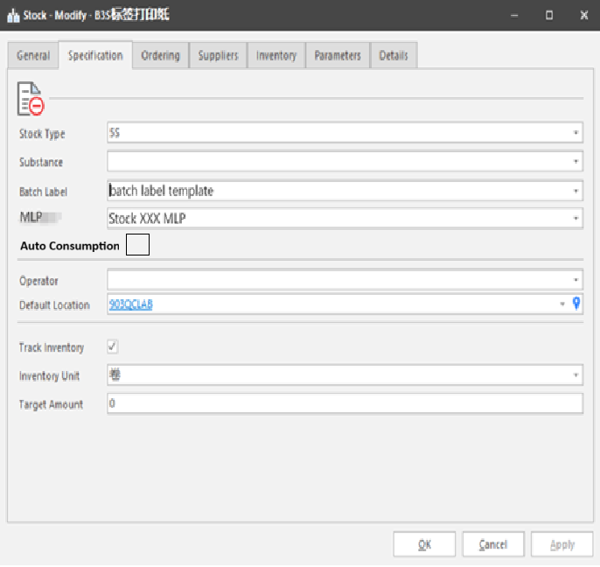

Label Template: A new stock batch label template will be created as per the below format.
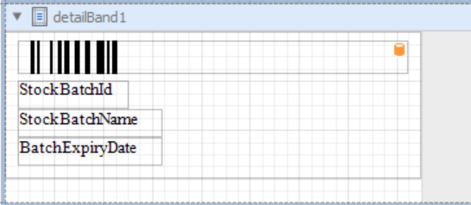

Stock Batch Creation Rules
1. Mandatory Fields Based on Auto Consumption
If Auto Consumption is checked in the stock master data: Expiry Date and Batch Number are mandatory when creating a stock batch.
Stock batch creation Task will be extended to include this validation.
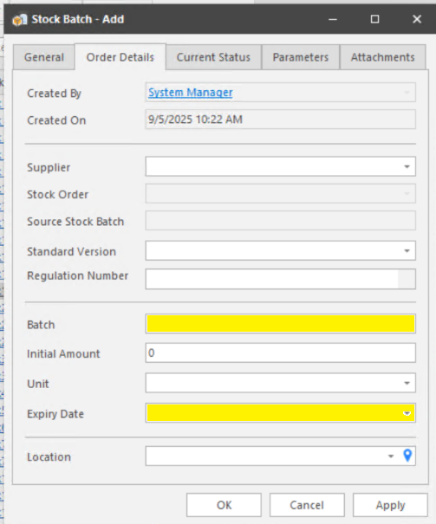

2. Stock Order-Based Batch Creation
When a stock batch is created via Stock Order Receiving: Expiry Date and Batch Number are mandatory.
Group Information:
Fetched from Stock Master Data,
Mandatory field,
User can modify the group value
Stock batch creation Task will be extended to include this validation.
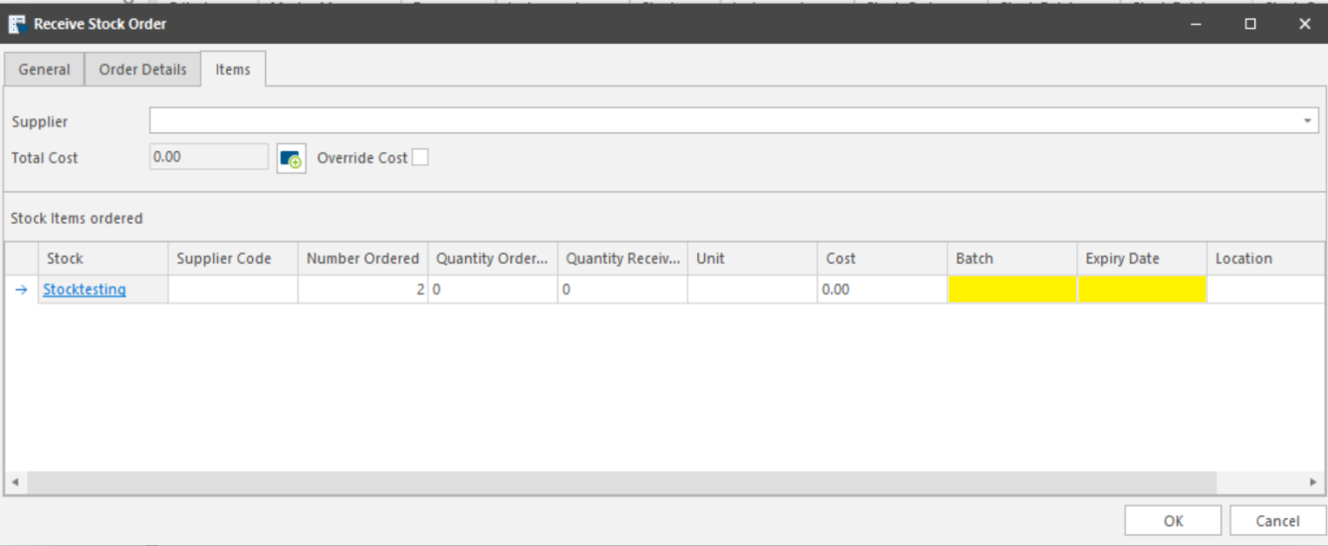
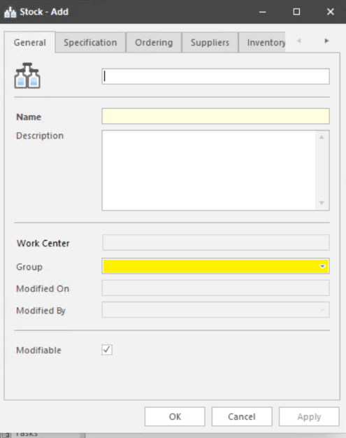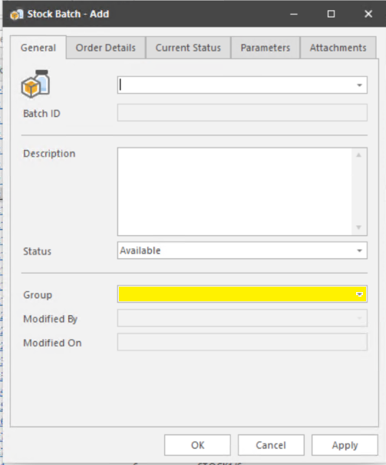

3. Label Printing Prompt
When a stock batch is created in the QCLAD system (either via stock order receiving or direct addition): A popup window appears asking for label printing quantity.
Default Settings:
Label Quantity: 1
Printer: Work Centre Printer
Label Template: Defined in Stock Master Data
User Options:
Modify label quantity
Choose a different label template
Select another QCLAD printer
Stock batch creation task will be extended to include this validation.

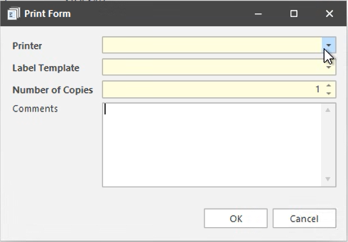
Step | Validation Item | Expected Behaviour
1 | Auto Consumption checked | Expiry Date & Batch Number required
2 | Stock Order Receiving | Expiry Date, Batch Number, Group required
3 | Group field | Pre-filled from master, editable, Mandatory
4 | Label printing popup appears | After Stock batch creation
5 | Default label quantity | 1
6 | Default printer | Work Centre Printer
7 | Default label template | From Stock Master

Sample Login
Sample login will be triggered when a stock batch is created in the QCLAD system: Either via Stock Order Receiving or by Direct Addition
Logic Flow
1. Check for MLP in Stock Master Data
System checks if MLP is selected for the stock item.
2. If MLP is Present
A Sample is created automatically.
Sample Type: IQC-CON
Work Centre: Pulled from Substance Master Data
Stock Batch Status: Moved to "Unavailable" folder in Stock Management cabinet
3. If MLP is Not Present
No sample is created.
Stock Batch Status: Directly released to "Available" status
Stock batch creation task will be extended to include this validation.

Step | Validation Item | Expected Behaviour
1 | Stock batch creation triggered | System checks MLP in stock master
2 | MLP is present | Sample created with type IQC-CON
3 | Sample work centre | Pulled from substance master
4 | Stock batch with sample | Moved to "Unavailable" folder
5 | MLP not present | Stock batch released to "Available" status

Sample Process
Sample Listing
Consumable samples are initially listed in the "Samples Pending Receiving" folder.
Sample Receiving
Upon receiving a sample, a sample label is automatically printed by the designated work center printer.
Sample Testing
Users perform testing of the received sample by following the Lab Testing Process Workflow.
All testing procedures and documentation are managed within the Sample Management cabinet folders.

Stock Batch Release
Sample Authorization
Once all tests for a sample are authorized:
If all results meet specification criteria, the system automatically releases the associated stock batch. The batch status changes to "Available".
Exception Handling
If any test fails to meet the criteria:
The system does not release the stock batch.
The batch status changes to "Await Decision".
Users can manually decide to either return or release the batch using the right-click menu.
Returned Batches
All batches marked as returned are listed in the "Returned Stock Batches" folder.
Batch Movement
Users can move the stock batch to its designated storage location using the "Move Batch" button

Automatic Consumption of Stock Batches During Testing
To enable automatic stock consumption during a test, the following preconditions must be satisfied:
Master Data Requirements
The Analysis Master Data must include:
Stock information
Consumption quantities
Unit of measurement
All linked to the corresponding IDH
Stock Availability
There must be available stock batches that correspond to the analysis being performed.
Consumption Deduction Logic
The automatic deduction of stock during testing follows a predefined logic, this logic ensures that:
The system checks for valid master data.
It verifies stock availability.
It deducts the appropriate quantity from the relevant batch automatically.
If the actual deduction amount is less than the target amount during the automatic deduction process, the system will pop up a window to remind the user of the relevant information.
- Stock batches are consumed based on the earliest expiration date, and if tied, by the earliest entry date. If a batch lacks sufficient quantity, subsequent batches are consumed in order until the required quantity is met.
- If the earliest expired stock batch lacks sufficient quantity, it is consumed first. The system then continues consuming from the next earliest expired batches sequentially until the required quantity is fulfilled.
      - Extend the test life cycle workflow, test completed event to include this logic.

Modifying Stock Batch Consumed for a Test
Accessing the Stock Consumption Window
Users initiate the process by clicking the newly added button on the Result Entry Window.
This action opens the Stock Consumption Window.
Viewing Stock Consumption Details
The system displays:
The stock batch used.
The amount consumed during the test.
The Planned deduction
Modifying Stock Consumption
Users can:
Change the stock batch.
Adjust the consumed amount.
Important Condition: Modifications are allowed only if the test has not been authorized.

As we already have the task for it (See screenshot below) and not sure if any additional changes are required for the same test.
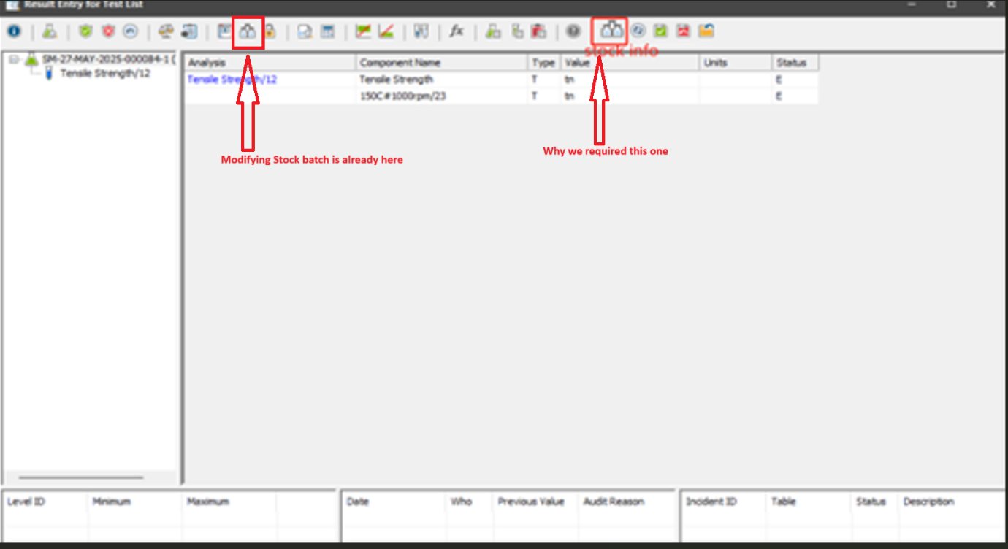

.NET Tasks

PrintLableTask
Used to print labels for stock batch is created in the QCLAD system (either via stock order receiving or direct addition)
On click, send print job with selected parameters:
Label Quantity
Selected Printer
Selected Template

CheckMLPTask
Logic Flow
1. Check for MLP in Stock Master Data
System checks if MLP (Material Lifecycle Plan) is selected for the stock item.
2. If MLP is Present
A Sample is created automatically.
Sample Type: IQC-CON
Work Centre: Pulled from Substance Master Data
Stock Batch Status: Moved to "Unavailable" folder in Stock Management cabinet
3. If MLP is Not Present
No sample is created.
Stock Batch Status: Directly released to "Available" status

StockBatchReleaseTask
Attache the task to system event line “Sample Authorization Completed”
As soon as the test authorization finishes, the task executes
If all test pass batch status becomes available
If any test fails batch status becomes Await Decision
If return – we will run “ReturnBatchTask” and update status as “R”
If accept – we will run “AcceptBatchTask” and update status as “A”

Hen_AutoConsumptionTask
The automatic deduction of stock during testing follows a predefined logic, this logic ensures that:
The system checks for valid master data.
It verifies stock availability.
It deducts the appropriate quantity from the relevant batch automatically.
Logic Flow Overview
Input: User provides a new stock and an associated IDH value.
Check Existing Data:
- Look through the current dataset.
- Verify if the (stock, IDH) pair already exists.
Uniqueness Check:
- If (stock, IDH) pair exists:
  - Notify the user or reject the insertion (duplicate entry).
- Else (pair is unique):
  - Proceed to add the new (stock, IDH) entry to the dataset.
Update Data Storage:
- Append the new stock with IDH to the dataset.
- Save/update the dataset (in-memory, database, file, etc.).
Confirmation:
- Confirm success to the user.

      - Additional condition will be added to check Auto Consumption is “T” or “F” in master data
If the actual deduction amount is less than the target amount during the automatic deduction process, the system will pop up a window to remind the user of the relevant information.
- Stock batches are consumed based on the earliest expiration date, and if tied, by the earliest entry date. If a batch lacks sufficient quantity, subsequent batches are consumed in order until the required quantity is met.
- If the earliest expired stock batch lacks sufficient quantity, it is consumed first. The system then continues consuming from the next earliest expired batches sequentially until the required quantity is fulfilled.

ReturnBatchTask
Attache the task to system event line “Sample Authorization Completed”
As soon as the test authorization finishes, the task executes
If any test fails batch status becomes Await Decision
If return – we will run “ReturnBatchTask” and update status as “R”

AcceptBatchTask
Attache the task to system event line “Sample Authorization Completed”
As soon as the test authorization finishes, the task executes
If any test fails batch status becomes Await Decision
If accept – we will run “AcceptBatchTask” and update status as “A”

Hen_ModifyingConsumptionTask
Open Stock Consumption Window
Display: Stock Batch + Amount Consumed
Check: Is Test Authorized?
No → Allow Modifications: Batch + Amount
Yes → Disable Modifications

Configuration Specification

Structure Table Updates

Update Table: Stocks
Field Name | Datatype | Comments
MLP | links_to mlp_header | Maintained in the same way as it is for other routine samples
Auto Consumption | Boolean | True/False value

Phrases
Modify Phrase: Stock_B_Task
Phrase Name | Comments | Action
Stock_B_Task | Add new Status: | U - Unavailable  W - Await Decision  R - Returned Stock Batches

Master Menu

Return Batch (Type - RMB)

Accept Batch (Type - RMB)

Explorer Folder

Await Decision

Returned Stock Batches

Unavailable

Workflow
Extend Test Life Cycle Workflow authorization Completed event to AutoConsumption stock batch

Change Log
Version | Authored by | Change Date | Change Details | Reviewed by | Review Date
1.00 | Madhur Sharma | 08-09-2025 | Initial Version

